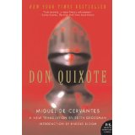

AP ENGLISH

Please read the First Part of Don Quixote. There are many different translations of the book. The one we will be using is by Edith Grossman. Translation matters. If you happen to get a translation that’s 100 years old, it will be more difficult to read. The Penguin Rutherford translation is also very good.

